Claim Registration screens documentation

1) Accident screen

2) Claims Screen – when OD Selected

3) Claims Screen – When PD / BI Selected

4) Service provider screen – when insurer selected

1) Accident Screen

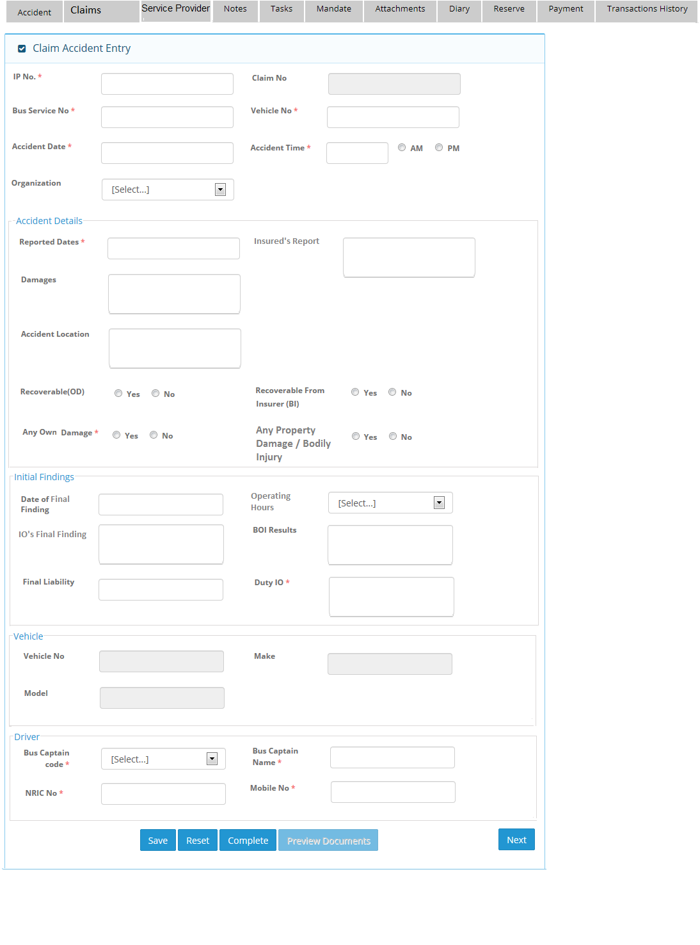

2)Claims Screen when Own Damage selected.

[Varun comments]
I) Can we change “Other Parties” grid header to “Parties” only? Change to Claim Entry
II) Can we change, first section caption name from “3rd party claimant ” to “Claimant Information”. Remain as it is.

 | Claim Type | Claim No | Claimant Name | Action
+/ - | OD
(when +) |  | OD-001 | DDC | << Select >>
+ / - | PD
(when +) |  | PD-001 | ABC | << Select >>
 |  |  |  | << Select >>
+ / - | BI
 |  |  |  | << Select >>

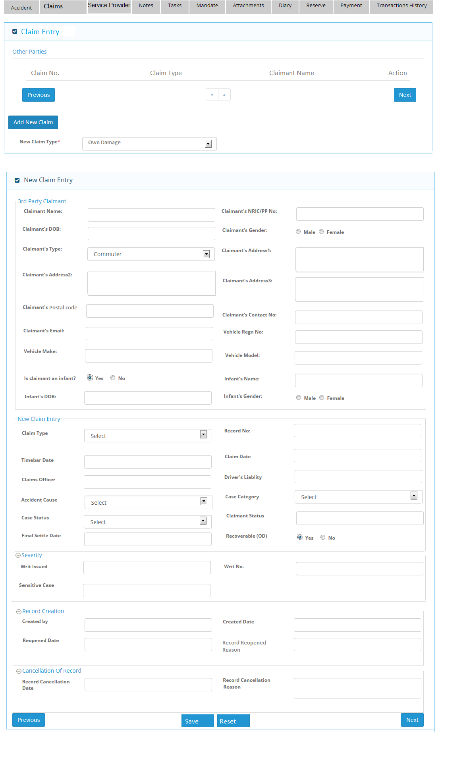

Remove.

3) Claims Screen – When PD / BI Selected

Note: For Bodily injury, user will choose new claim type as “ Bodily injury” and same screen will come for this
option.
[Varun comments]
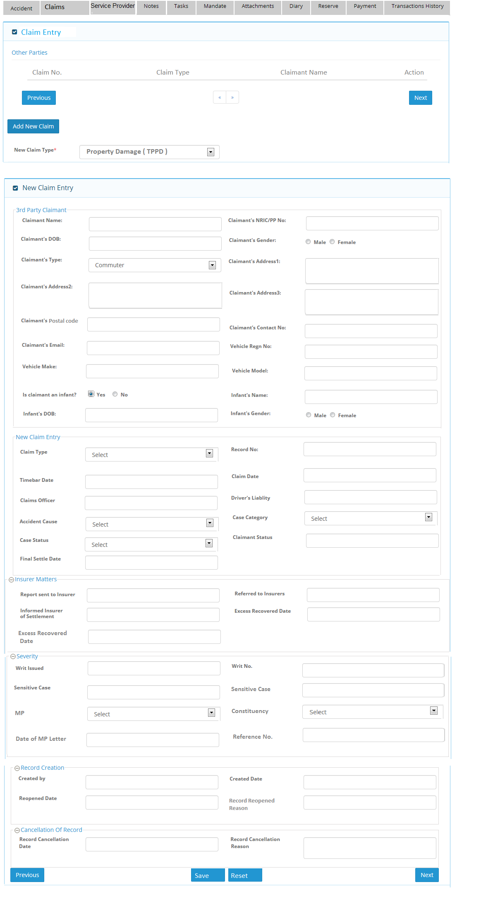
I) Can we change “Other Parties” grid header to “Parties” only. Change to Claim Entry
II) Can we change, first section caption name from “3rd party claimant” to “Claimant Information”. Remain as it is
Change to New Table Structure

4) Service provider screen – when Insurer selected

 | Claim Type | Claim No | Claimant Name | Party Type | Action
+/ - | OD
(when +) |  |  |  | Insurer | << Select >>
+ / - | PD
(when +) |  |  |  | Insurer | << Select >>
 |  |  |  | Workshop | << Select >>
+ / - | BI
 |  |  |  | Workshop | << Select >>
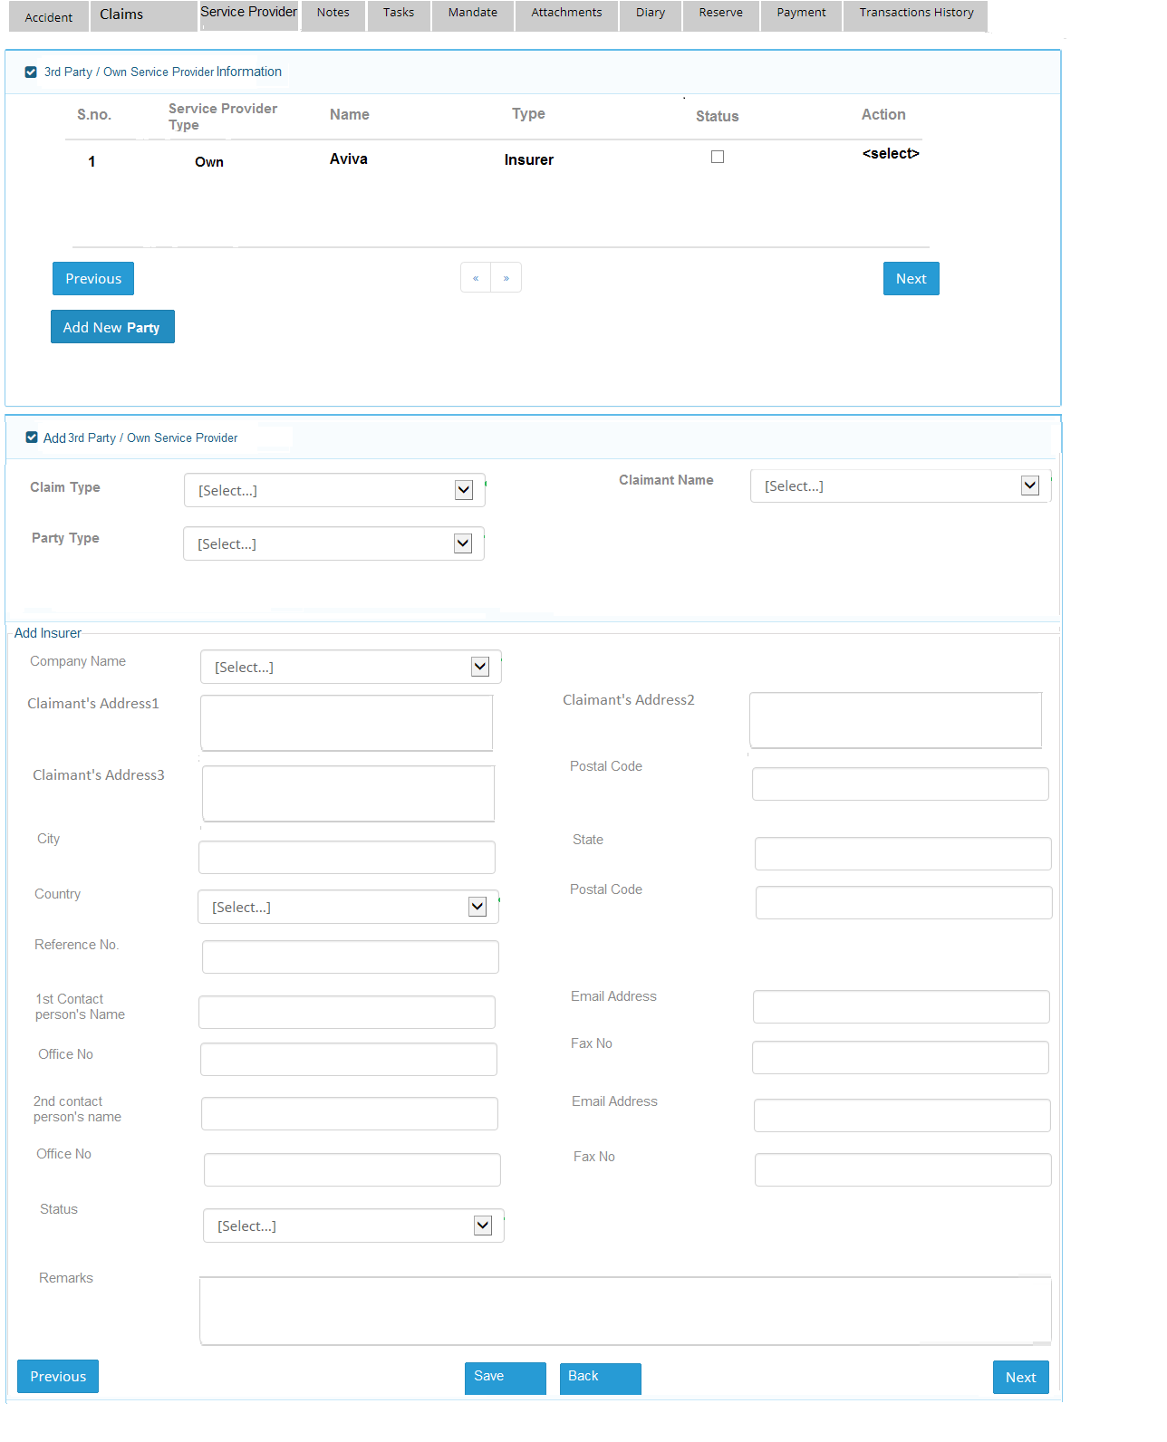

Please include Tasks & Attachments

